**Wei Liang** **SP17**

**CST 2309-E286**

**Lab#4**

**Prof. Sancar Avcioglu Feb 15, 2017**

**Q1-5: Browser: Google Chrome**

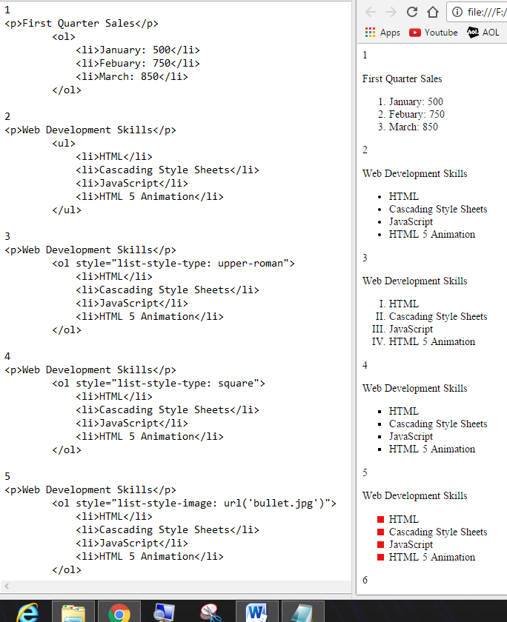

**Q6-7: Browser: Google Chrome:**

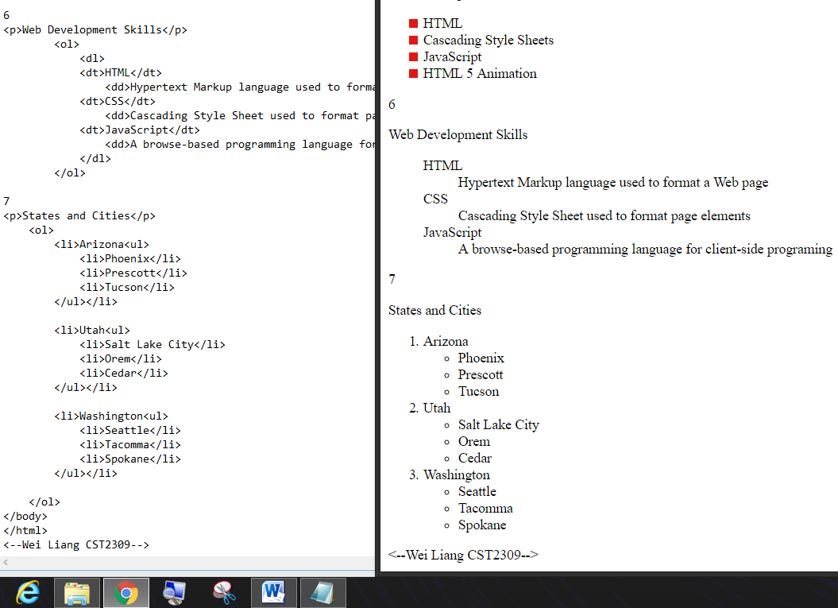

**Q8:**

Graphic artist use Lorem Ipsum to avoid critics or accidently plagiarize; but most importantly, Lorem Ipsum is used as a text dummy for the typesetting industry to test the readable content of a page when working on one’s website layout.